- If you have limited backrest movement issues and hear a beep each time a button is depressed on a foot control or touchpad, you may need to adjust the chair limit settings. Use the procedure below to check the potentiometers before adjusting the chair limits.

Remove the two Allen screws toward the toe of the chair on the bottom of the seat upholstery. Slide the upholstery off by gently pulling it towards the toe of the chair frame while lifting it.

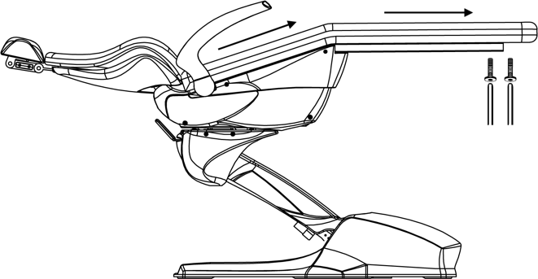

Inspect the condition of the plastic backing of the chair’s seat upholstery. If excessive damage to the plastic is visible, you will need to purchase a new seat cushion. You can also install a cross-support plate, which is recommended when purchasing a new seat cushion. Resetting the limits and installing upholstery with a damaged plastic base can damage the potentiometer arm and other components.



YES NO
Inspect the chair potentiometer assembly. Verify the arm is parallel to the return spring on the right side of the chair if viewing from the back to the toe.
Inspect the set screw in the arm to the potentiometer shaft and verify it’s secure. The chair back needs to be in the upright position to gain access to the set screw. If the chair back is in the down position, you will need to place the chair in service mode.
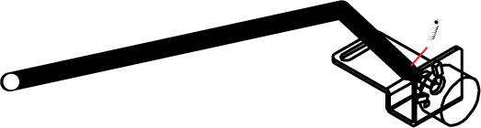
Service Mode:

Remove the chair pump cover and locate the main PCB. See the images below.

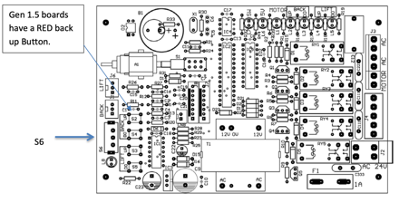

Slide S6 into the down position to place the chair in service mode. When the switch is in the correct position, the LED light below the switch (L8) will illuminate. This indicates the chair is now in “service mode.”

It’s not recommended to operate the chair in service mode for an extended period if waiting on components. The chair can be able to travel beyond its limits and damage the frame or plastic covers. The chair presets and auto return will not function in service mode.

Raise the backrest to obtain access to the set screw on the chair potentiometer arm. Verify the set screw is secure. *If the set screw was loose, it’s possible that the POT may have also rotated * If the potentiometer has been rotated, you may need to re-center it in some cases. There are two ways to set the limits on the Mirage dental chairs. Auto mode and manual mode. See the options below. It’s not recommended to re-program the limits in auto mode when a Swing Mount Delivery system is attached to the chair.
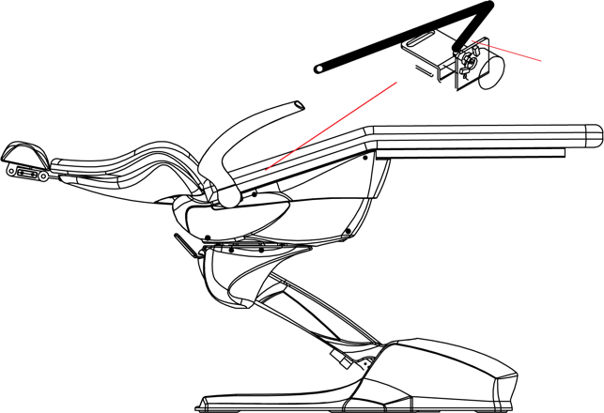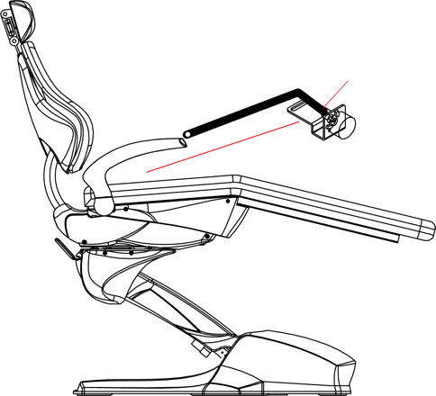
Chair Back Down Chair Back Up

Adjusting the chair limits:
Auto Limits: | Manual:
With the chair in service mode. Press and hold the button labeled “Back Up” (S2) for 5 seconds. When you first press the button, the main board will beep. After the button is depressed for 5 seconds, you will hear an additional beep, and the chair will begin to move on its own. Release the button when this occurs. | To set a limit for the Mirage operatory chair, perform the following procedure. Locate the slider switch labeled S6. See figures on next page for locating switch (S6). This will put the chair into service mode. Using the touch pad or foot control, move the chair to the desired position. See below for detailed instructions on setting each limit.
Result:
The chair will go through two complete cycles of movement. The first cycle is the Maximum travel that the chair is capable of. The second complete cycle the chair performs will deduct about 10% of the first measured travel for movement 1. If the chair errors out while in auto limit mode, the potentiometers need to be inspected. If the chair errors out on the base movement, stop the procedure and check the base potentiometer prior to proceeding. Once the chair completes two cycles, it will rest in the exit position and will beep repetitively. Reverse the position of (6). The light L8 will turn off.  If the chair base moves up and down rapidity, disconnect the safety plate or remove any obstructions under the safety plate. | DOWN:  Using the manual controls, Recline the backrest fully. Raise the backrest slightly from this point and press the BACK DO button on the main PCB board. Slide (S6) Switch on PCB to off position. Then raise the back rest up. Then lower it to verify the desired setting has been achieved.  UP:  Using the manual controls, Raise the backrest fully. Lower the backrest slightly from this point. Press the BACK UP button on the main PCB board. Slide (S6) Switch on PCB to off position. Then Lower the backrest. Then Raise it to verify the desired setting has been achieve.

If the plastic bottom of the upholstery is damaged, you will need to install the cross-support plate. This will prevent the chair seat from dipping down in the lower portion of the seat frame.
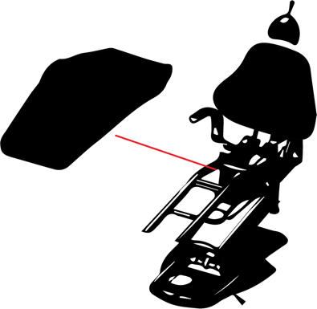
Mirage Base potentiometer
Remove the pump cover from the dental chair. Standing at the back of the dental chair you will see the potentiometer on the right side just above the base of the dental chair.

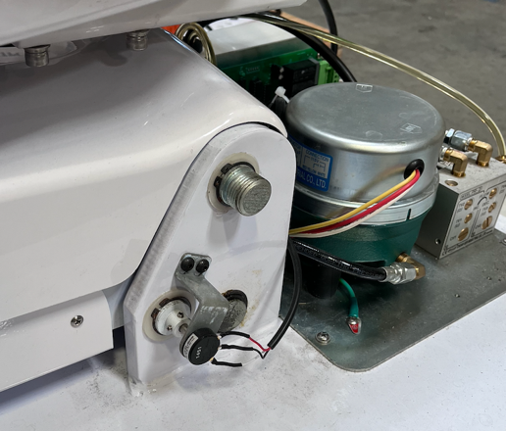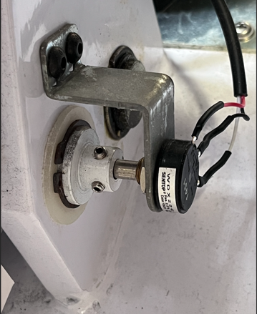

Verify that the set screws are secured on the potentiometer collar. If the set screws were loose, you may need to re-center the potentiometer position to the center.

Measuring the potentiometer resistance with a voltmeter

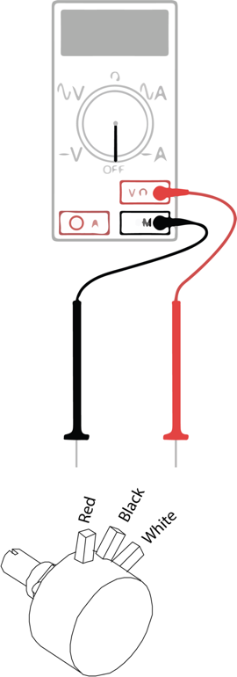 | Measured values:  White to Red = 1K Ω  Red to White = 1K Ω  Black to white = 0 – 1K Ω  Red to Black = 0 – 1K Ω  Adjust the wiper to vary the value of the potentiometer. If the measured values are correct. Measure them at the connector to the PCB board to verify the wire harness has not been damaged.  Potentiometer Model: RV245YN

